**PROJECT TITLE**

**Student Name: Balwinder kaur UID:23bca10388**

**Branch: BCA Section/Group 2B**

**Semester: 3RD Date of Performance:**

**Subject Name DESKTOP PUBLISHING LAB Subject Code:23CAP-204**

1. **Aim/Overview of the project: Making a travel poster**
2. **Task to be done:**

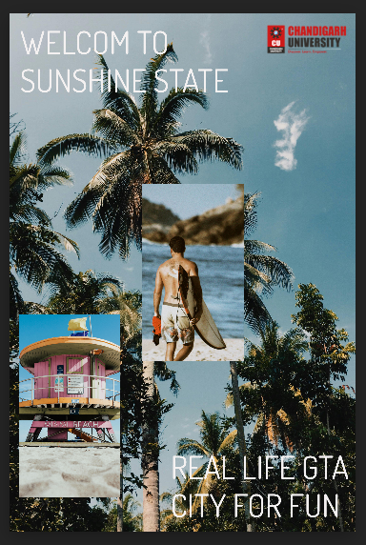

1. **Steps followed in making the project:**
2. **First take an image as background for the poster.**

**2.Then add the logo and desired text to the image .**

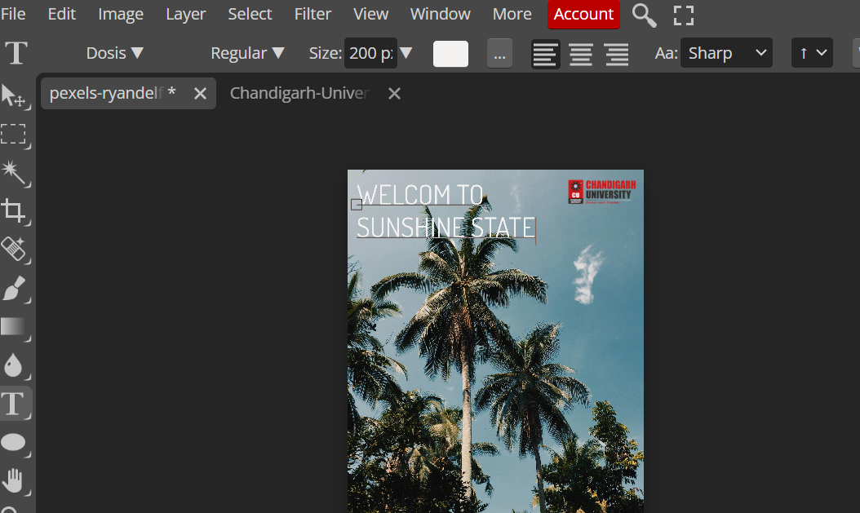

1. 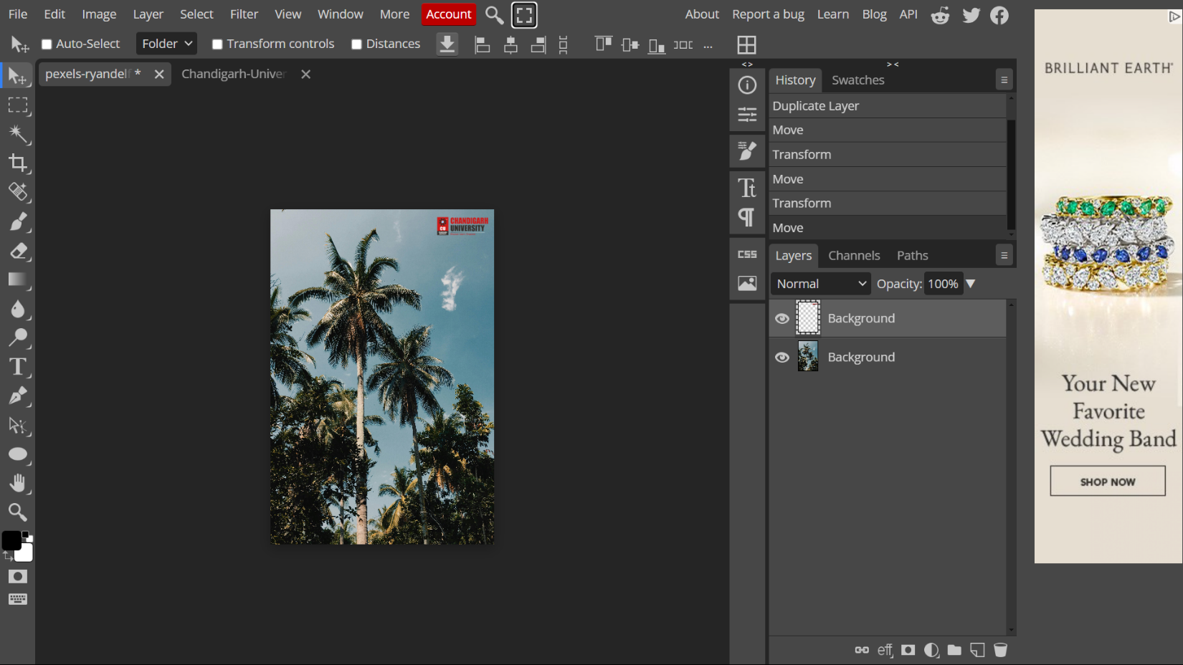**Now add the text to image.**
2. **Now add a rectangle shape and using a clipping mask merge image inside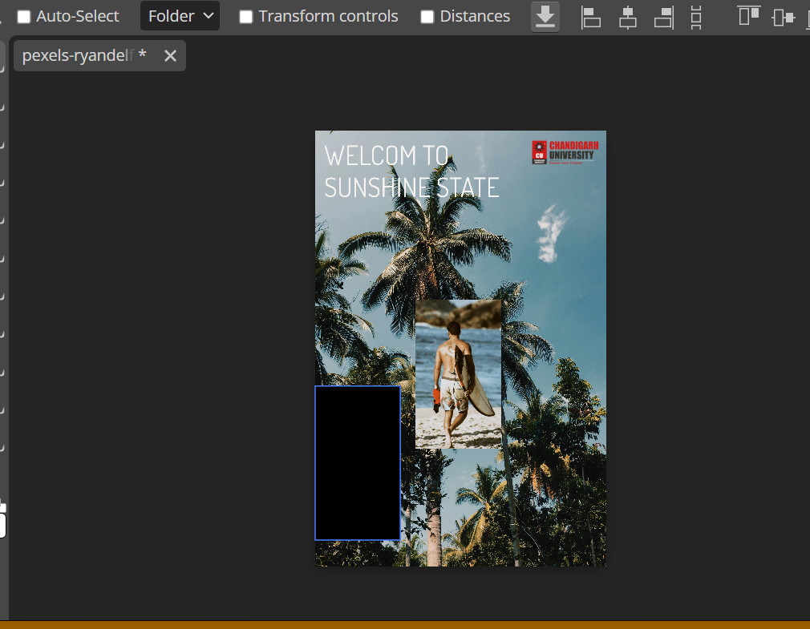 the shape and adjust it accorrdingly.**
3. **Now use smart object.**
4. **Repeat it for another image.**

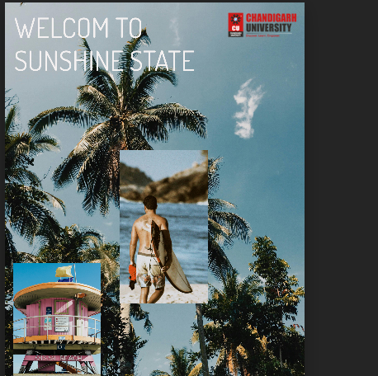

1. **Now add the finale text to image using Typography.**

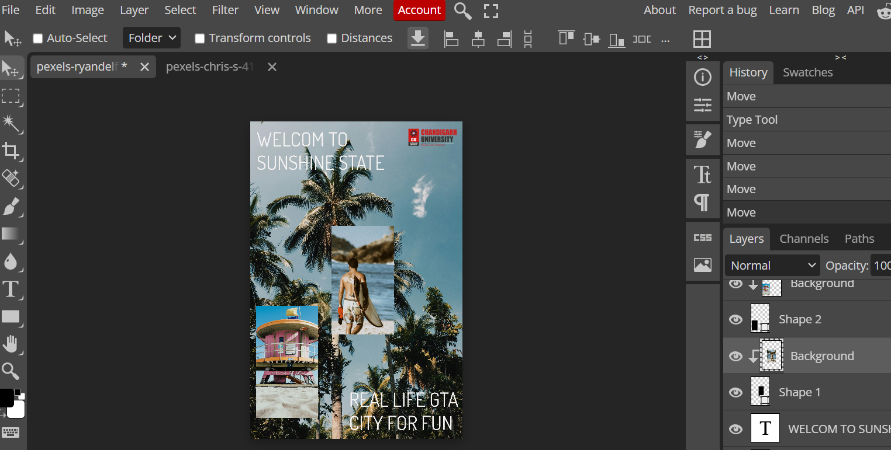

1. **Use Text Wrap to edit and style text.**
2. **Result/Output/Writing Summary:**



**Learning outcomes (What I have learnt):**

**1. Use of different tools.**

**2. editing and styling of text.**

**3. image improvisation.**

**4. Better understanding of tools.**

**5. learnt how to make meaningful output and images for use.**

|  |  |  |  |
| --- | --- | --- | --- |
| Sr. No. | Parameters | Marks Obtained | Maximum Marks |
| 1. | Demonstration and Performance (Pre Lab Quiz) |  | 5 |
| 2. | Worksheet |  | 10 |
| 3. | Post Lab Quiz |  | 5 |

**Evaluation Grid:**